**User documentation**

**1.1 General description**

The "OpenCloud Game" is a Python-based interactive game where users can login and test their knowledge of Python by answering a series of questions. By providing correct answers, players earn points and can track their progress. The game aims to enhance Python programming skills through an engaging and educational gaming experience.

**1.2 Login Screen**

* Upon launching the application, you will be presented with a user login screen.
* Enter your login credentials (username and password) to access the application.
* If you enter incorrect login credentials, you will receive an error message stating, "Username or password is incorrect! Please try again."



**1.3 User interface**

**1.3.1 Select Number of Questions Screen**

* After successful login, you will be directed to the Select Number of Questions screen.
* On this screen, you will see:
  + Your name, the points you have earned until now (top-right).
  + A logout button (top-right).
  + An (!) button to access the explanation screen (top-left).
  + An 'Your profile' button that shows a summary of the player's last ten games (top-left).
* The available options for selecting the number of questions will be displayed, ranging from 5 to total amount of questions available in the database (in increments of 5).   
  For example, the current total amount of question is 35 so it is presented to the user (Figure 1).
* Choose the desired number of questions using the provided interface.

Figure 1.

**1.3.2 Game Screen**

* Once you proceed from the Select Number of Questions Screen, the game will begin.
* The total number of questions will be based on your selection from the previous screen.
* A title showing the number of the current question out of the total number of questions you were asked to answer.
* Each question will be displayed along with four multiple-choice answers (Figure 2).
* Click on one of the answers to make your selection.
* If your answer is correct, it will be marked in green (Figure 3). If incorrect, it will be marked in red (Figure 4).
* Below the answers, there will be a button to continue to the next question.
* Throughout the game, there will be an option to exit the game if needed.
* The name of the user and the points earned so far will be displayed on every screen, along with a logout button and a button to navigate to the Introduction screen.

Figure 2.

Figure 3.

Figure 4.  
 **1.3.3 Introduction Screen**

* From the Select Number of Questions screen, you can navigate to the Introduction screen by clicking on the "!" button.
* The introduction screen will provide an overview of the game and explain the rules, including how to select answers and navigate through the quiz.
* A 'logout' button (top-right).
* A 'Back to menu' button return to Select Number of Questions Screen (bottom-left).

**1.3.4 Profile Screen**

* From the Select Number of Questions screen, you can navigate to the Profile screen by clicking on the "Your Profile" button.
* Motivational phrase: A motivational phrase is displayed within quotation marks. The phrase is randomly selected based on the user's current accuracy rate.
* Session graph: The session graph is displayed as a horizontal bar chart. The x-axis represents the games from oldest to newest, and the y-axis represents the accuracy percentage.
* Total games and current accuracy: The total number of games played by the user and their current accuracy rate are displayed as separate headings.
* A 'logout' button (top-right).
* 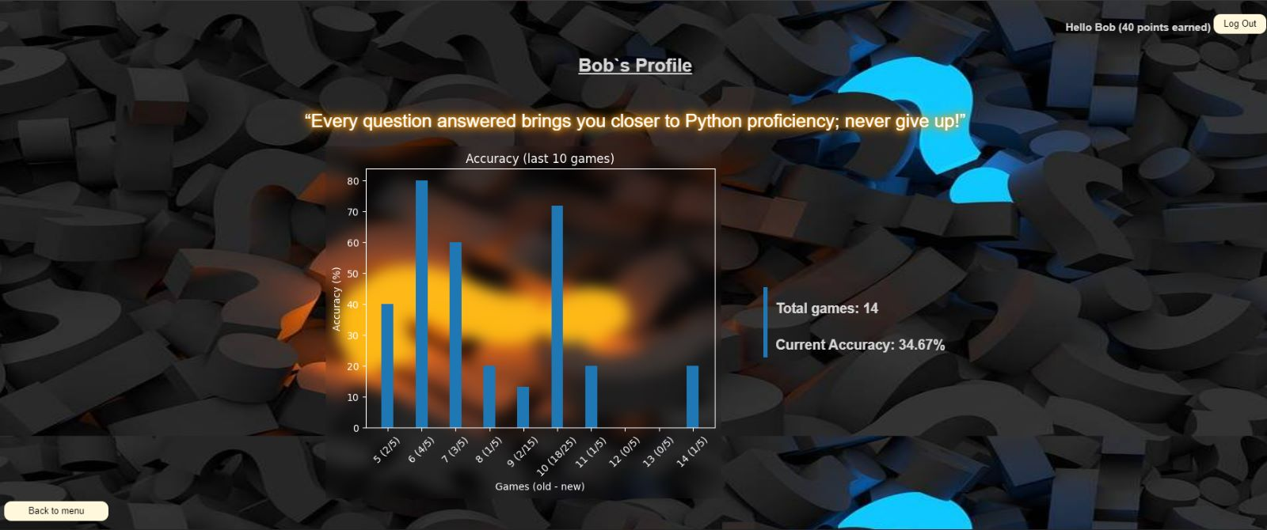A 'Back to menu' button return to Select Number of Questions Screen (bottom-left).

**1.3.5 Results Viewing Screen**

* On the results viewing screen, a pie graph will be displayed, showing the percentage of correct and incorrect answers.
* For up to a maximum of 15 questions, also the questions that you answered incorrectly will be highlighted with a red circle and the questions that you answered correctly will be highlighted with a green circle.
* You will have the option to exit the game from this screen.



**1.4 Manager interface**

**1.4.1 Menu Manager Screen**

* After logging in, you will see the Menu Manager screen.
* This screen will have two buttons: "Insert Question" and "Update/Delete Question."
* Clicking on the "Insert Question" button will take you to the Insert Question screen.
* Clicking on the "Update/Delete Question" button will take you to the Update/Delete Question screen.

**1.4.2 Insert Question Screen**

* The Insert Question screen allows you to add a new question to the application's question bank.
* You will see a form where you can enter the question, options 1-4, and select the correct answer number from a combo box.
* If you leave any field empty, you will receive an error indicating the unfilled field.
* תמונה שמכילה צילום מסך

  התיאור נוצר באופן אוטומטיAfter filling all the required fields, you will be returned to the Menu Manager screen.

**1.4.3 Update/Delete Question Screen**

* The Update/Delete Question screen allows you to modify or delete existing questions.
* You will see a combo box where you can choose the question you want to update or delete. By default the first question will display.
* Selecting a question will open an edit form where you can modify the question, field 'correct' have options 1-4 to select the correct answer number from a combo box.
* The form will also have buttons for update and delete operations.
* After clicking on the update or delete button, you will be returned to the Menu Manager screen.

